Aim: Study of various types of sensors, their specifications and applications.

Software Requirements:
- Windows or Linux Desktop Operating System
- MS Word
Objectives:
- To understand the working principles of different types of sensors.
- To study real-world applications of sensors in various industries.
- To learn how to select a suitable sensor for a given application.

Prerequisite:
- Basic knowledge of electronics and measurement systems.
- Familiarity with physical parameters like temperature, pressure, light, motion, etc.
- Understanding of analog and digital signal concepts.
- Awareness of common electronic components and circuits.

Theory:

Q1. What is Sensor?
A sensor is a device, module, or subsystem that detects and measures a physical property from the environment and converts it into a signal that can be read, displayed, or processed by an observer or an electronic system (like a computer or microcontroller).

Q2. Explain Working of a sensor.
• Input (Physical Quantity):
Detects a real-world parameter (e.g., temperature, light, pressure, motion, humidity).
• Transformation:
Converts this physical quantity into an electrical signal (voltage, current, resistance change, digital signal).
• Output:
Sends the signal to a display, controller, or computer for interpretation or action.

Q3. List various types of sensors, their specifications and applications.

Name | Specification | Applications | Sensor Image | Price (INR)
Accelerometer Sensors | These sensors work by measuring either static or dynamic acceleration through an electromechanical sensor. The accelerometer converts the displacement into a digital electrical signal for processing. | Navigation and control applications | 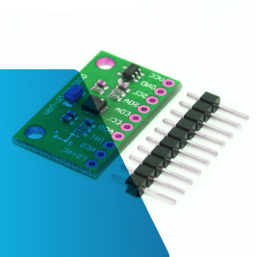 | 50-200
Gyroscope Sensors | A gyroscope sensor operates on the principle of angular momentum and gravity.  It uses these forces to determine orientation and measure rotational motion. | Camera-shake detection systems, motion sensing for video games, and vehicle electronic stability control systems | 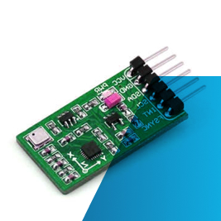 | 100-300
Temperature Sensors | Like the name, temperature sensors can detect thermal parameters.  After detection, they provide signals to the inputs of used devices. | The most commonly used temperature detectors (RTDs), thermistors, and semiconductor-based integrated circuits (IC). | 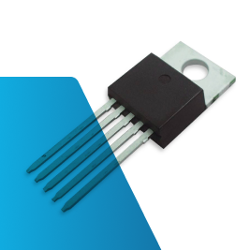 | 20-80
Vision and Imaging Sensors | Vision sensors detect the presence of objects or colours within their fields of view. After that, they convert this information into a visual image for display. | Visual tracking, detection, recognition, reconstruction, and stereo matching. | 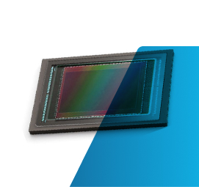 | 500-2000
Proximity Sensors | Proximity sensors operate on various scientific principles to detect the presence or absence of objects without physical contact. They convert the detected information into an electrical signal. | Moulding, packaging, printing, and food and chemical processing. In these areas, contact with the object may cause damage or abrasion, which these sensors avoid. | 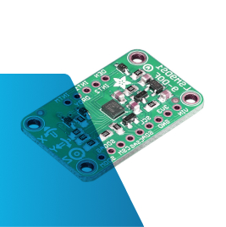 | 40-150
Infrared Sensors | Using these sensors, you can emit or detect infrared radiation to sense specific characteristics of their surroundings. It includes the motion and heat of the objects. | Applications like radiation and spectrum measurement, search and track systems, thermal imaging systems, and gas detection. | 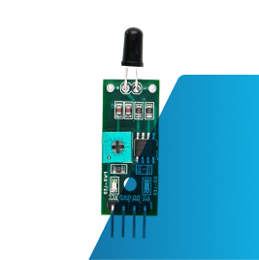 | 20-100
Radiation Sensors | These sensors measure radiation emissions or levels of radiation that a source produces. Radiation sensors can detect different radiations like gamma and x-radiation. | The uses of these sensors are present in tasks including measurement, protection, and search. | 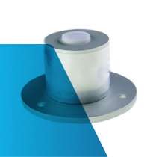 | 1000-3000
Metal Sensors | These are electronic or electro-mechanical devices used to sense the presence of metal in various situations. | Detecting Metallic objects and other metallic devices. | 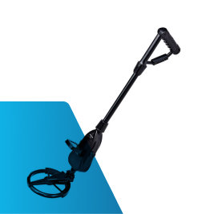 | 300-1200
Particle Sensors | Depending on the applications, these particle sensors are categorized into aerosol, solid, and liquid particle sensors. | Determining air quality. They can count and size the number of air particles. In food packaging, businesses use metal-based nanoparticles in their sensors. | 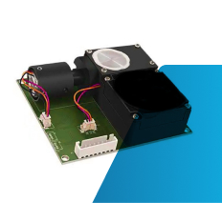 | 1500-4000

Conclusion
Successfully studied various types of sensors along with their specifications and applications.

